MicroMagic modelsailors
10 rules for happy racing

- boats with the wind coming from different sides: the boat with the wind on the right side has the right of way, the boat with the wind on the left has to give way.

- boats with the wind on the same side: the one closest to where the wind comes from has to give way, the boat further away from where the wind comes from has the right of way.

- boats on the same course and with the wind on the same side: the leading boat has the right of way, the trailing boat has to give way. If they have their main boom at different sides, §1 applies.

- a boat approaching a hindrence, land or entangled boats shal be given space to awoid the hindrence.

- the marks for the course must not be touched.

- if overlap is established at a mark, 4 boat lengths before the mark, shall the innermost boat be given space to round the mark. If there are several boats inside shall they all be given space. (Overlap is established if the front bow is inside a line at 90 degrees to the leading boats centerplane at the aftermost point).

- A boat that has the right of way shal always keep the course and speed in order to make it possible for the boat to give way to do so. The boat to give way shal do so in good time, not in the last possible moment.

- A boat which has violated one of the rules 1 – 7 above, has to sail clear of all boats and turn 360 degrees around itself. Thereby the penalty has been taken.

- If there is a colission, then at least one of the boats has broken one of the rules above and has to take a penalty at once, see §8.

- If You are walking along the control area, always walk behind other sailors, never in from of them.

Per Schiøttz
Skovshoved sept. 20th 2007
MM DEN 1

The eleventh rule: It’s Your duty to have fun !!

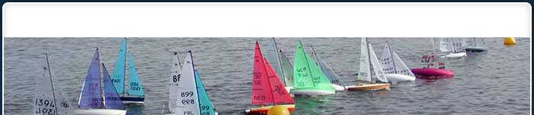

MicroMagic modelsailors 10 rules

These 10 rules should be taken as a suggestion for discussion on which rules we would like to follow. We can avoid having any rules or we can use the international racing rules or we can make our own which anyone can learn. This is an attempt on the last possibility.

